IE343 Statistical Machine Learning

20170240 박기범

* Question A

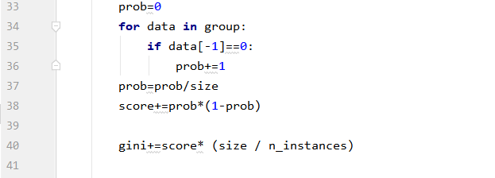

* Question B
* Question C
* Question D
* Question E
* Question F
* Question